”GET OUT OF THE CITY”

An Animation by Kasper Jensen

STORYBOARD

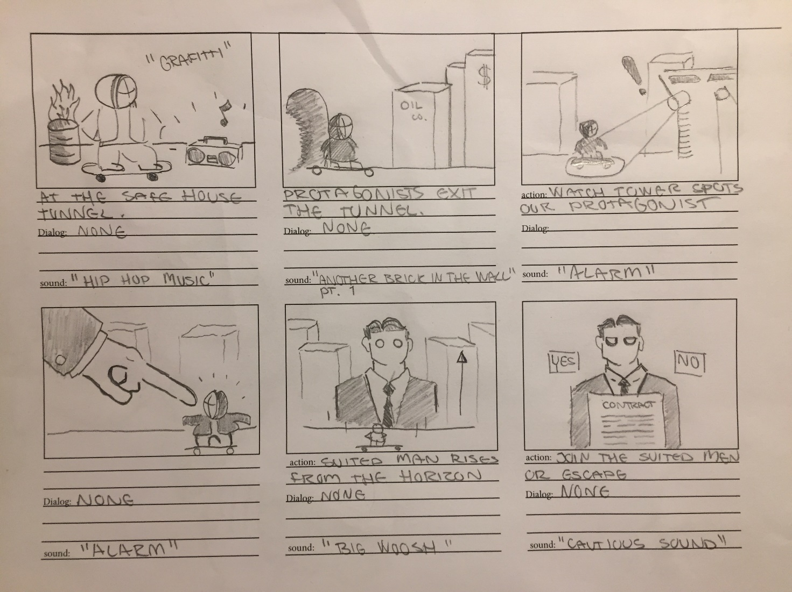

**Interaction:**

The user will have to choose the fate of the protagonist. To join the suited men in the big city, or to escape completely.

DESCRIPTION OF THE STORY

**RESUMÉ:**

In a dark world of big men in black suits. An entire city where everything is black, white and squared. From the money hungry contracts to the company headquarter buildings. A young teenager lives in refuge in the underground, where art and music is praised. On a skateboard he tries to make his way out of the industrial world of political power. The only safe places from the suited men are the underground tunnels, where true colors are graffitied on the walls. Our main character will travel a dangerous path through the city, in order to escape. A journey in which you will have to prioritize wealth and freedom. Our main character will be “headhunted” for job opportunities in large commercialized companies, but with the cost of true free will. Will you be another brick in the wall, or will you be a rogue? The choice is yours.

**MESSAGE:**

Will you become what you despise the most, and retrieve great power? Or will you skate your own path, unknowing of the future.

**GENRE / MOOD:**

Horror, Dark Setting, Heroic & Rebellious

NARRATIVE CURVE

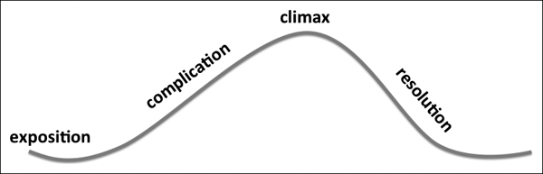

**Exposition:**

The Protagonist leaves “The Underground” and is exposed to the dangers in The City.

**Complication:**

Our protagonist gets spotted by one of watchtowers in The City.

**Climax**:

The Man emerges and poses an ultimatum. The Protagonist cannot escape without acting.

**Resolution:**

The Protagonist will either escape and live life in freedom, or accept The Man’s offer a live with wealth.

DRAMATURGIC ELEMENTS

**Exposition:**

Background Music (N.W.A – “Fuck Da Police”)

Metro Sound Effects

Colorful Environment

**Complication:**

Background Music (Pink Floyd – “Happiest Days of Our Lives”)

Dark Environment

**Climax**:

The Narrative Block. The man will act as the obstacle, emphasized by his size and red empty button-likes eyes.

**Resolution:**

Snoop Dogg – “Nothing But a G Thang” if “NO” button = true

Pink Floyd – “Waiting For The Worms” if “YES” button = true

STYLE TILE

Inspiration from the Constructivism Style

**Characteristics in The Style:**

The style of the city and characters within it is very minimalistic, often using squared shapes and straight lines in black and white to symbolize the cold order that dominates the city. The red creates a great contrast, to express an alarming feeling, making the setting seem dangerous and unfriendly. The men in suits carry a mysterious and empty character, as only their blank red eyes are visible. Our main character will be in great contrast to this style, as shown on the skateboard below, representing bright colors and natural organic shapes.

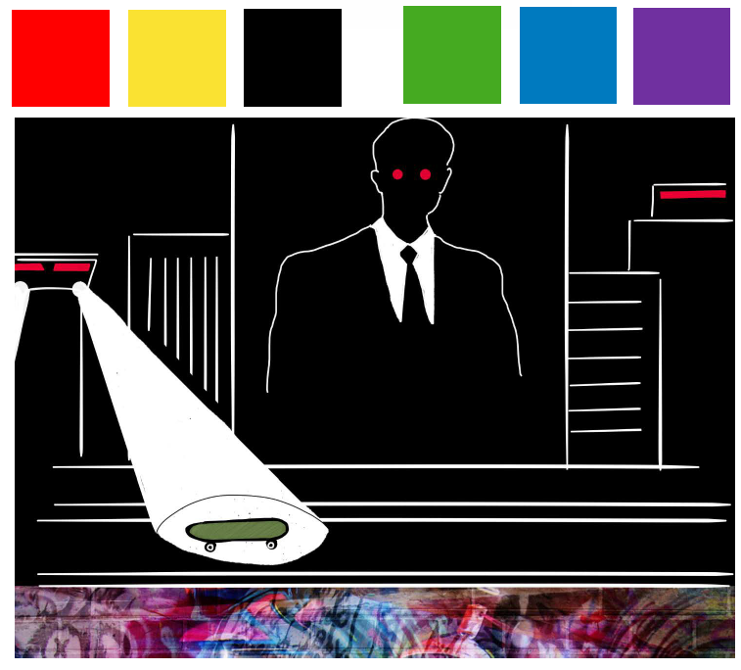**Typoraphy: SOLID**

CHARACTERS WORKSHEET

**PROTAGONIST “TYRONE”**

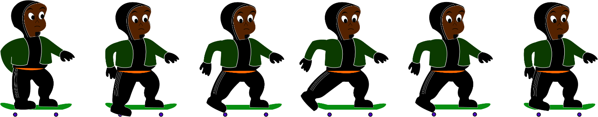

Animation principles: Tyrone moves in a linear constant speed, creating the effect of riding a skateboard. His leg move in a circular motion, to act as the “wheel” element for his movement. Tyrone’s eyes will move, so he’ll be looking down, when kicking a step. Tyrone is standing in a prepared stance, adding action to his character.

**VILLAIN “THE MAN”**

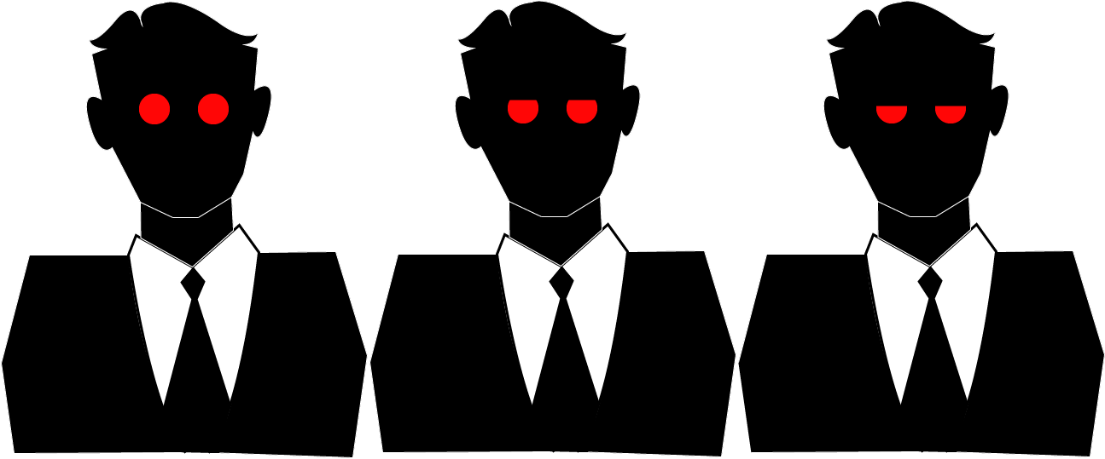

Animaiton Principles: The Man’s animation is timed slower than Tyrone, to emphasize his bigger size, and colder personality. I avoided to animate the man too much, to maintain a simple, mysterious and cold character.

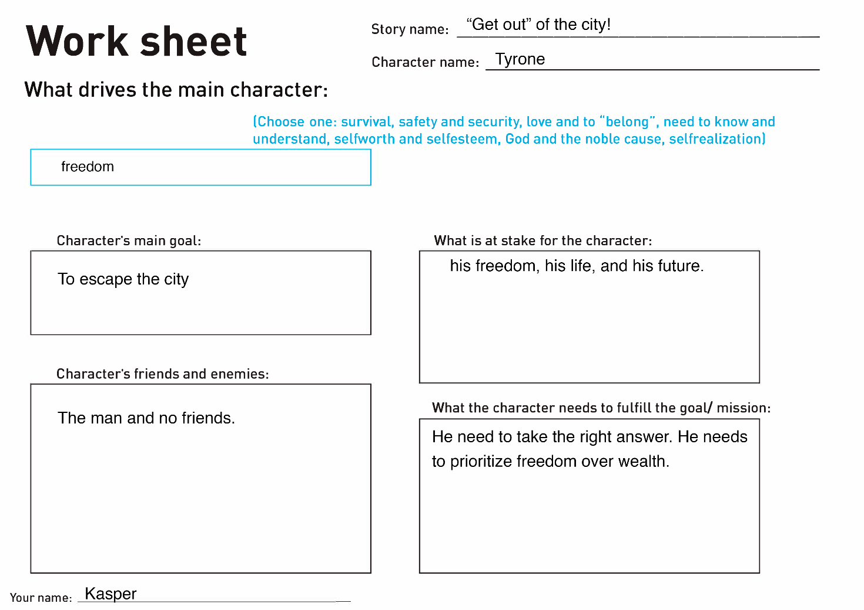

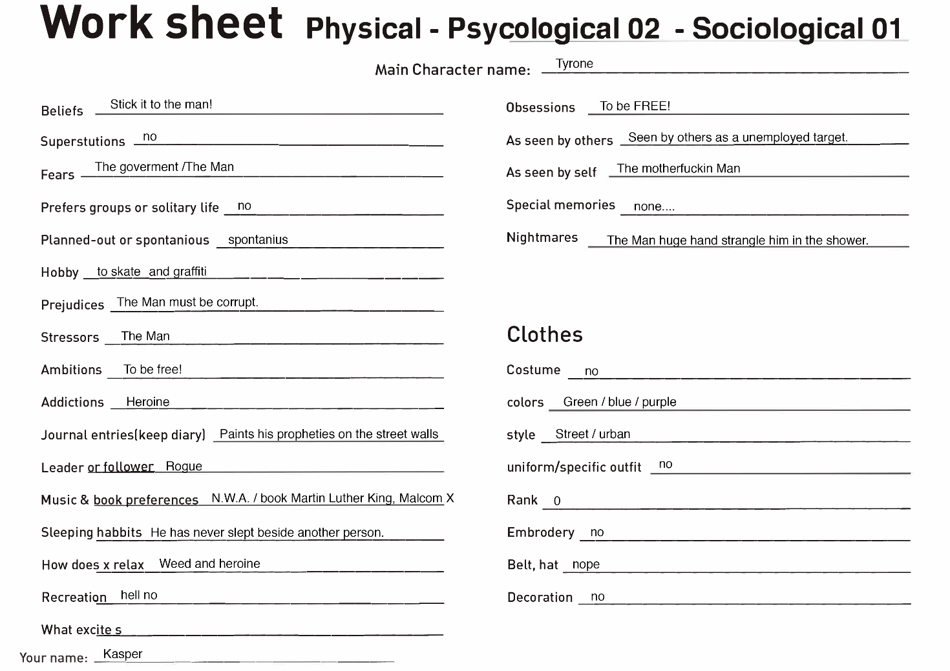

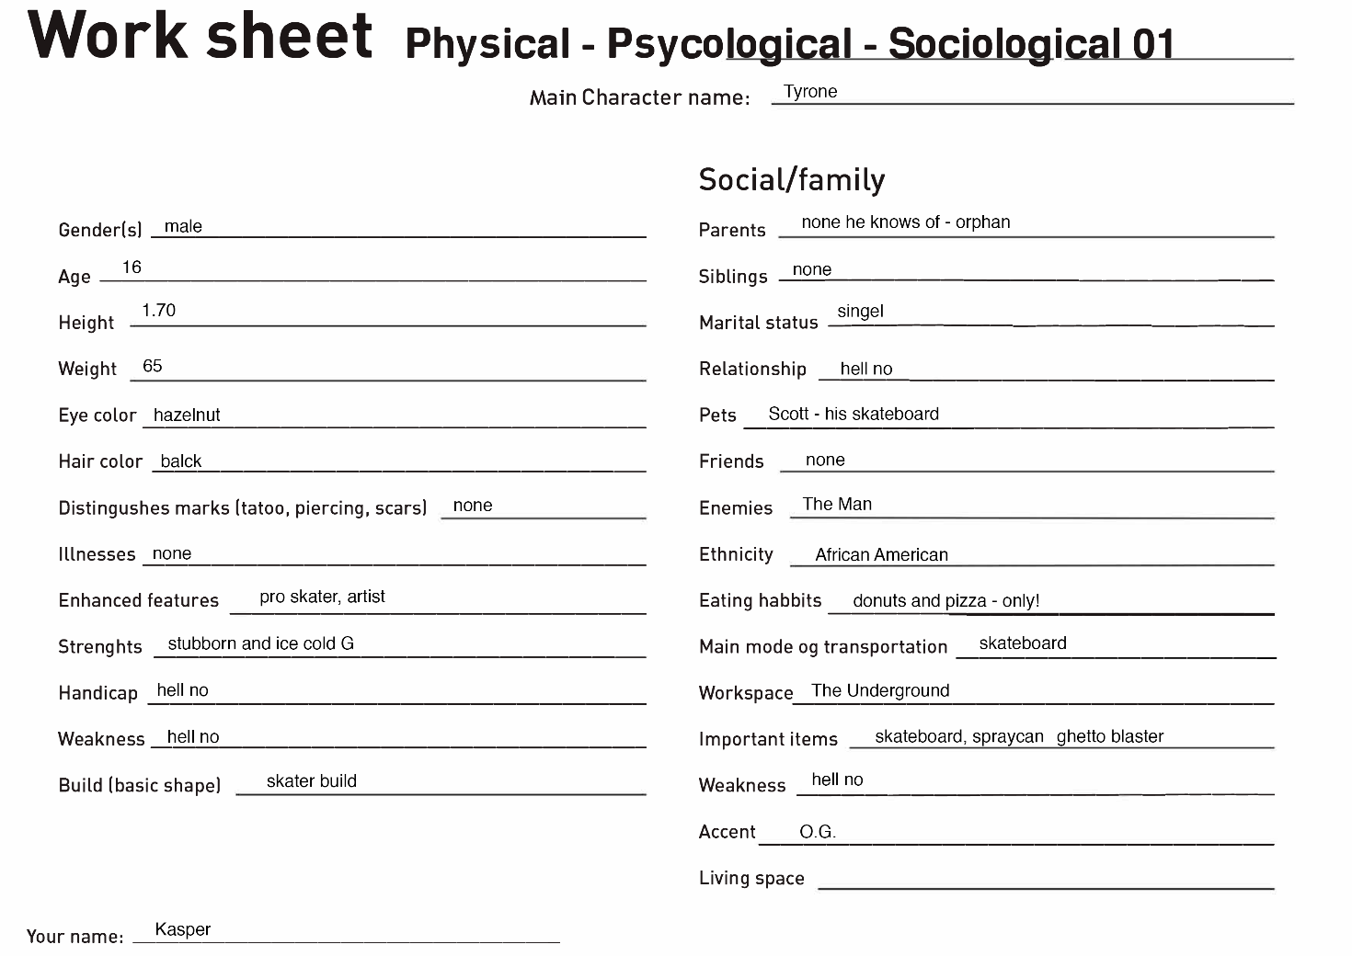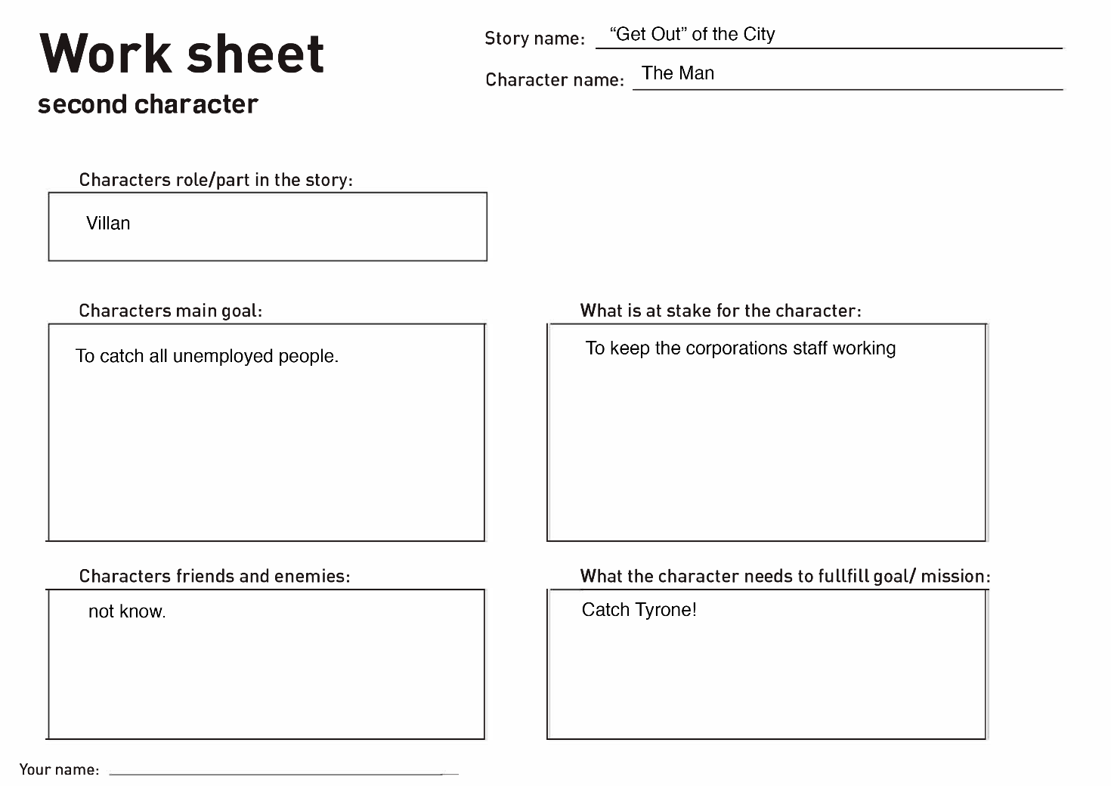

BACKGROUND

(background images include foreground elements)



**Exposition:**

**Conflict:**



**Climax:**

LINK TO SPRITE SHEET ANIMATION

“Tyrone Skate Cycle”

[www.linlines.dk](http://www.linlines.dk)